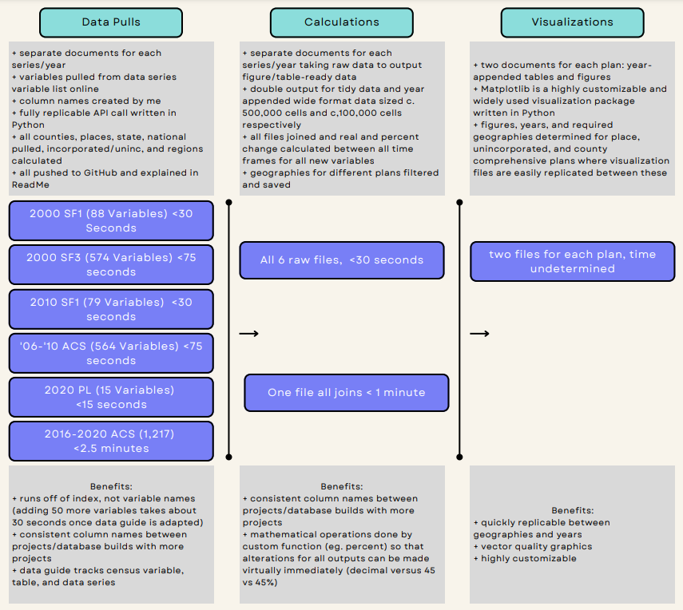
Hypothetically… if you needed to adjust the percentages for statistical analysis instead of visualization, you could change the function in your calculation file and have that output ready for all geographies in less than 5 minutes.
If you needed to change the years, you simply change the input for beginning, mid, or last year in the data pull files and re-run them – rerun the calculations – and have the data ready for visualization in less than 8 minutes.
If you have a new data series – say poverty for children – requested by planning, you’d spend the morning finding all of the individual variables needed for input from the various data series, writing those into your data guides, adding a new line to the data pull codes, writing the calculation to transform the raw data into visualization-ready data, and then it’s finished forever.
Year over year – or geography to geography – if a datapoint like minority population is drastically different, the parameters you would have to custom-change between plots (x axis tolerance, for example) should only take a couple minutes. The tables will stay the same.

Figure Process for Tables and Plots is relatively simple. As many style parameters as possible are hardcoded at the beginning of each document. This includes standard things like font families, weights, and various color codes. It also includes code to format axes appearance and labels based on the datatype (year, percent, etc.), autofill citations, and set the figure size for optimal use in a Word document or other product. A temporary data-frame is created for each plot or table filtered for geography, year/ time frame, and relevant datapoints, and then a figure is created without altering the source data. Matplotlib is used to create all plots and tables. Below you can find the parameters that you can customize:
Tables:
- Size
- dpi
- Raster vs. vector image
- Edge presence and color (variable by cell, or, for example, by column header outlines vs table cell outlines)
- Font family, font, font size, font color
- Cell color and opacity
- Padding (distance) between features like cell edge and values
- Citation and title placement
- Column and row scaling
- Column width is extra customizable – can be based on set value or on minimum required width for text/value
- Text placement in cell (left, right, center… can be different for headers and cell values)
Plots:
- Type: line, multiline, bar, multibar, stacked bar, pie, tree, etc.
- All of the same things can be customized as the tables
Scenarios for Comp Plan Visualizations:
- One geography, one datapoint (not percent change) over time
  - Proposed visual: line plot
- One geography, one datapoint (percent change specifically) over time
  - Proposed visual: bar plot
- One geography, shares of 100% over time, two factors
  - Proposed visual: stacked bar, single bar, or pie plot
- One geography, shares of 100% over time, more than two factors
  - Proposed visual: stacked bar or pie plot
- Multiple geographies,

